**Extended Project Qualification**

An investigation of how Howard Shore used musical devices in his score for The Lord of the Rings

By Nathan Guth

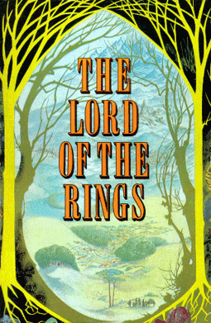

[1]

# Production Notes

This document can be printed. However, it is strongly recommended to read or have a digital copy available, as with it will be supplied the audio and video tracks referenced to many times throughout this report.

Whilst they are not necessary to complete the reading of this paper, having access to them will greatly aid in the understanding of the topics discussed in this paper.

TRACK# *Title of the track*

Use these red track markings as indication of which track provided with this paper is being discussed.

All audio extracts are provided in .FLAC format. This common audio file type can be read and processed by most modern media players (VLC, Windows Media Player, etc.…) and on most operating systems.[2]

**All audio tracks are being used for educational and instructional purposes only. The author of this EPQ does not own any of the media distributed with this project and is not profiting from them in any way. All rights go to their respective artists and authors, which are credited to at the end of this document**

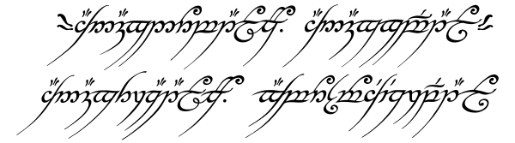

[3]

Contents

Production Notes 2

Contents 3

1 Introduction 4

**1.1** **Aim and Objectives** 5

2 Howard Shore’s Score 6

**2.1** **Regarding *The Lord of the Rings*** 6

**2.2** **The Story** 7

**2.3** **Howard Shore’s Score** 8

**2.4** **Research** 10

**i.** **Primary Research** 10

**ii.** **On the work of Doug Adams** 11

3. A Study of Leitmotifs 12

**3.1** **The Leitmotif** 12

**3.2** **The Shire** 13

**i.** **The Story Briefly** 13

**ii.** **Motifs** 14

**iii.**  **In Scene** 15

**3.2** **The Fellowship** 16

**i.** **The Story Briefly** 16

**ii.**  **Motifs** 17

**iii.**  **In Scene** 18

**3.3** **Gondor and the Realms of Men** 19

**i.** **The Story Briefly** 19

**ii.**  **Motifs** 20

**iii.**  **In Scene** 21

4 Conclusion 23

Bibliography & Filmography 24

# Introduction

This Extended Project Qualification will be tending to the subject of film music, and in particular the work of Howard Shore, the Canadian composer who wrote, orchestrated and produced the music of the film trilogy *“The Lord of the Rings”* by Peter Jackson.

This project aims to explore the works created by Howard Shore for The Lord of the Rings trilogy and to examine his composition. By evaluating techniques and methods he made us of, this report aims to create an understanding of their use and effectiveness in advancing the story-telling and atmosphere of The Lord of the Rings by Peter Jackson. By using transcripts of scores, official commentary and external sources and opinions, this project will serve as a demonstration of how a thematic approach to composing a score for a picture can be carried out, and how it was effectively done by Howard Shore.

This topic was chosen as the joint subject of both music, in particular film music, and the study of movies in general. From this mix came the decision to study the effect of film music in movies, and how the composer uses his work to add to the narrative on screen.

The selection of the franchise or film in particular that would be studied was perhaps the easiest step. There are a multitude of scores and soundtracks that are globally acclaimed to be some of the best film music. The Lord of the Rings is a soundtrack that has been praised numerous times for its complexity, and how ingenious it is. Although it may be recognisable, the decision was made to study it in particular, as much could be learned from taking a closer look at it, and by studying it musically.

In order to conclude on this subject, research will be done. Firstly on the soundtrack itself, its composition process and release, but also on the musical devices and techniques used on particular themes and ideas throughout.

## **1.1 Aim and Objectives**

As stated by the title of this EPQ, its primary aim is to lead an investigation and research operation on the work by Howard Shore in his score for *The Lord of the Rings*. In order to achieve this aim however, it was decided that additional objectives would be set to be completed during the progression of this topic. All of these objectives would build towards the completion of the main aim, which is to, by the end of this report, give a reasoned judgement of Howard Shore’s use of musical techniques, and to what effect.

* Firstly, in order to understand a soundtrack, it was thought necessary to understand the structure of the work. The EPQ aims to lay bare the structure of the soundtrack, and to do so while taking into account how it was composed, for example how long the soundtrack is.
* A short summary of the story of *The Lord of the Rings* will be given, to aid the audience’s understanding of some of the decisions made by the composer.
* Another secondary objective of this EPQ is to not be too detailed in musical technicality and analysis. The audience of a soundtrack is not required to have musical knowledge to appreciate it, and so it was decided that the same would have to be in order to understand the use of musical devices. This EPQ therefore aims to explore Howard Shore’s technique, whilst remaining accessible to all types of persons, with a musical background or not.

These aims will be addressed both throughout this project, but also in the conclusion, which will build on all collective objectives to try and conclude on the “investigation” laid out by the main aim.

# Howard Shore’s Score

In this section the aim of understanding the structure and composition process of the score will be addressed. Additionally, a brief summary of the story will be given. Some background information on the film trilogy is provided, as well as some history and background concerning Peter Jackson’s choice of Howard Shore as his composer.

## **2.1 Regarding *The Lord of the Rings***

*The Lord of the Rings* is an epic work of fiction written by John Ronald Reuel Tolkien between 1937 and 1949. Since its first publication, it has become the best-selling novel of all time[4], and has accumulated worldwide fame and popularity as one of the greatest works of fiction ever written.

The Lord of the Rings film trilogy was released from 2001 to 2003. Produced almost entirely in New Zealand, it is a faithful and accurate adaptation of the novels, with minor story and pacing changes to suite the story better to the big screen. Many agree that no franchise in the history of film making was as meticulously and carefully planned. The many years of production and coordination that were spent at the end of the 1990’s created one of the most critically acclaimed collection of films[5].

The work of Peter Jackson and his dedicated crews and teams enthralled the many fans of Tolkien’s work, but his well-adapted films and techniques engaged and touched a much wider audience too.

During the theatrical releases of each film, an extended version was also released for each movie. These extended cuts contained up to 45 minutes of extra footage and music each, as well as behind the scenes commentary and interviews. Due to the increase in run time and musical material, this study will be focusing on the Extended Edition of each respective film, and will be ignoring the differences between the theatrical and extended cuts.

The Lord of the Rings, Theatrical Releases:

2001 The Fellowship of the Ring

2002 The Two Towers

2003 The Return of the King

The Lord of the Rings, Extended Editions:

2002 The Fellowship of the Ring Extended Edition

2003 The Two Towers Extended Edition

2004 The Return of the King Extended Edition

## **2.2 The Story**

To tell the story of *The Lord of the Rings* in a few words is to skip and compress nearly all of Tolkien’s work. However, to understand the significance and context of some of the plot points and use of music in the films, one would benefit in having some knowledge of the series of events that unfold in all 3 books of *The Lord of the Rings.*

The start of the first book sees us introduced to The Shire and its inhabitants the Hobbits, of which we learn of a few in particular. Bilbo Baggins is the 111 year old uncle of Frodo Baggins, who live together in Bag End. After celebrating his 111th birthday, Bilbo departs from the Shire after leaving his magic ring to Frodo, all of this being of great interest to the wizard Gandalf the Grey, a friend of Bilbo’s and regular visitor to the Shire. After seeking council from his elder, Saruman the White, another wizard, Gandalf concludes that this ring is the long lost Ring of Power of the dark lord Sauron, who is rising again in the land of Mordor in the east. Sauron cannot rise to his full strength without the Ring of Power however, as part of his soul is attached to the object.  
Gandalf therefore sets Frodo on a quest to Rivendell, city of the Elves, along with 3 other hobbits Sam, Merry and Pippin, who are chased by the 9 servants of Sauron, the Ringwraiths. After many perils and encountering a ranger named Strider, the Hobbits make it to Rivendell. There, called by Elrond, lord of Rivendell, a secret gathering of representatives of the races of Middle Earth is held, where the fate of the Ring is decided upon. This council, the council of Elrond, is where the Fellowship of the Ring is created; whose mission is to destroy the Ring in the fires of Mount Doom, in the heart of Mordor. There, Strider’s heritage as the heir to the throne of men is revealed, and that he is Aragorn, last of a long-lost line of Kings.  
After Saruman betrays the free peoples of Middle Earth, he sends orcs after the Fellowship. Being forced to cross ancient dwarven mines Gandalf dies fighting a demon of old ages. The Fellowship escapes, but is then split up after another of its members, Boromir is killed. From there, Frodo and Sam are left alone to destroy the ring, and the remaining members are caught in the war between Men and the forces of Isengard, Saruman’s kingdom. Gandalf is brought back from the dead by greater powers, and sent to Middle Earth as Gandalf the White, to complete his task of securing the peace. After helping men triumph over Saruman’s forces, Gandalf convinces Rohan, a large state under the rule of King Théoden, to ride to the aid of Gondor, another kingdom of men under attack by Sauron and his forces. After many battles and perils, Frodo and Sam destroy the Ring just in time to save the armies of men. Aragorn is crowned king of Gondor, and the Hobbits return to their Shire.

This is the main story arc followed by The Lord of The Rings, and all 3 movies stay faithful to it. The majority of changes the films had to make were to omit certain details, scenes and stories from the novels, as they were simply too long and detailed to put to screen entirely.

[6]

## **2.3 Howard Shore’s Score**

When Peter Jackson and the creative team behind TLORT films were preparing for the task of filming three pictures back to front in 1999, he asked Fran Walsh, a writer and producer of the trilogy, to lay in a ‘temp track’ over the rough cut of animated sequences and story boards of all three films[7]. A temp track is a temporary mock-up of a film’s soundtrack, assembled from pre-existing music prior to the real, commissioned score being composed and recorded[8].  
  
This is common practice when preparing production for a movie[9], and has been used in cinema for a very long time[10]. It allows the director to have guidelines for the mood, atmosphere and pacing of scenes, all without the need to have music pre-composed, as it is too early in the making process to do so. Temp tracks are then replaced with the composed soundtrack later. It was during this selection process that Peter Jackson found himself drawn to Howard Shore’s previous works, including *‘The Silence of the Lambs’, ‘Ed Wood’* or *‘The Fly’.*

The Canadian composer Howard Shore, notable for his film scores, has composed over his career more than 40 soundtracks. His work on The Lord of The Rings trilogy earned him his first Oscar, as well as a Grammy, a Golden Globe nomination and a BAFTA[11].

Anyone who has delved into the novels written by JRRT, whether it be *The Lord of the Rings, The Hobbit* or *The Silmarillion*, is aware that they are much more than stories and novels, but that Tolkien has created within them an alternate world. This feat of world building has led to the development of one of the most detailed, complex and rich universe of fiction containing cultures, historical accounts of these cultures, relationships between various lands and species, and a clear account of the functionings of these lands.

The soundtrack referred to in this project is known as the Complete Recordings. With each film released an official theatrical soundtrack, each a single-disk album, was also published. However, while these contained many of the tracks used in the films, they were cut-down and very short in comparison to the scale of the works used in the pictures. That is why, in 2005, after much popular demand, official soundtracks were released, known as the Complete Recordings. These multi-disk albums totalled nearly 10 hours of soundtrack, the vast majority used in the films. Included with these soundtracks were official annotated scores, commentary and information about the composition process written by Doug Adams[12].

The Fellowship of the Ring - 3 CDs (total 180:35)

The Two Towers: - 3 CDs (total 188:13)

The Return of the King: - 4 CDs (total 228:17)

Total: 598:05 or 9hrs 58mins

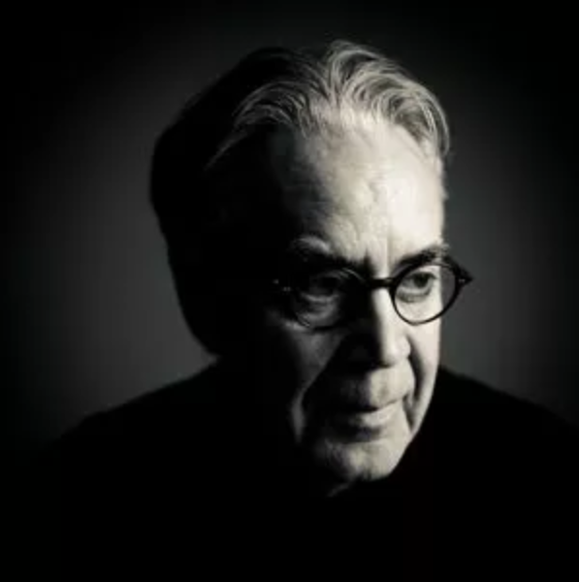The volume of the Complete Recordings allows for much more detailed inspection of the progression of themes and motifs, and being able to speak of the music that was used directly in the pictures allows for greater study of its effectiveness the films. As the majority of the Theatrical Soundtracks is included as part of The Complete Recordings, this project will focus on the contents of the Complete Recordings, and ignore the differences between the two releases of TLORT soundtracks.

By the time Shore had finished scoring the films, he had written over 10 hours of continuous music, with themes for nearly every character presented in the movies, in addition to multiple motifs for some of the lands, some for nature, and themes for the ring of power.

In total, more than 70 individual themes can be heard throughout the soundtrack, with many having variations on their main motifs. [13]

## **2.4 Research**

### **i. Primary Research**

In order to take a close look at the innards of Shore’s soundtrack, information is needed, information about nearly all different aspects of the music. From how it was composed, to the individual notes making it up.

In order to study the music, for research, the actual tracks were needed. Thus began the arduous process of listening to all 135 tracks of the soundtrack. As is later detailed in this document, the primary area of focus was to identify and locate specific themes, and to keep track of their occurrences.

Once familiarised with the library of tracks, the selection of themes that would be suitable for inspection could begin. The criteria for the selection of motifs are laid out in further sections. These had to be decided upon, and had the objective to try and represent the soundtrack as a whole using a restricted number of themes.

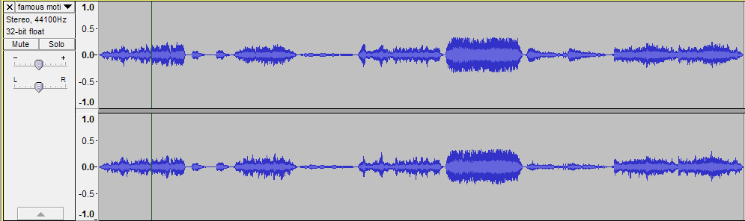The 3 themes that would be used selected, it was then necessary to select suitable musical extracts for each of these themes, as well as occurrences of any modifications or subthemes. Using audio manipulation software, rough cuts were made. First, shortlists were created, compiling a collection of appearances of the same theme, then a quick selection process eliminated the ones that didn’t fit the criteria. In order for an extract to be considered suitable, it was decided that it should:

* Be of suitable length (<1min)
* Contain enough of the studied theme
* Contain the theme in a recognisable way
  + - The audience’s ability to recognize musical extracts being very varied, the recognising of a studied theme in an extract had to be made as easy as possible.

Following the cutting of audio, musical transcriptions of the tracks were made. This was not done for all extracts, but was for every base theme. This was for several reasons. Firstly, it would let audience members familiar with musical notation be able to have a greater understanding of the music being played. Secondly, even to a more inexperienced audience, it would show some musical aspects of the music that might be harder to pick up on when listening to the track. For example, the tonality of the music.

Following personal work done on the score, many secondary pieces of research were going to be needed.

### **ii. On the work of Doug Adams**

When Howard Shore began his work composing for *The Lord of the Rings*, he looked into documenting the process and work he was about to go through. His mind turned to Doug Adams, a musical journalist that had he had already become aware of. Shore noted “His work consistently stood out”[14]. As a result, when Shore started his work, he invited Adams to write an article documenting the work on *The Fellowship of the Ring.*

During the 4 years that it took Shore to create a musical image of the books by JRR Tolkien, Adams followed that process during the entire period. As Howard Shore studied the books, watched the films and composed, Doug Adams was continuously keeping track of Shore’s work.

After the trilogy was completed and released, and the soundtracks officially published however, it became important to Shore that the score should be organized, and that a comprehensive view of the music was made. It was then that Doug Adams agreed to write this comprehensive account.[15]

*“The Music of The Lord of the Rings: A comprehensive account of Howard Shore’s Score”* is the results of nearly 10 years of work from Doug Adams. The more research Adams did, the more Shore gave him access to his archives – sketches, scores, notebooks, recordings, film and videos. From 2001 to 2010 Adams absorbed and organized the years of work by listening to recordings, and studying the scores. The produced book is an account of all those findings, and includes snippets of scores, as well as a CD containing disused themes and recordings, as well as interviews with Howard Shore.

During the research of this EPQ, it was important to have many and varied sources of information. However, above all else, primary sources are of most value when looking for detail and truthful information. That is why this report by Doug Adams was used as the primary source of information regarding the scores by Howard Shore. Due to Adams working very closely with Shore for such a long period of time, this source can be considered to be the ‘last word’ on any conflicting or non-matching pieces of information. Having found many other studies on the music and sonic space of *The Lord of the Rings*, none of them were found to be as detailed and specific as *The Music of The Lord of the Rings*.

# 3. A Study of Leitmotifs

In this section, the more detailed analysis of Shore’s work will be carried out. The primary focus of this analysis will be the leitmotif. This musical device or technique is how Howard Shore built his score, from the very start.

## **3.1 The Leitmotif**

The Leitmotif, from German meaning ‘leading motive’[16] is a recurring musical theme or idea.  
To this definition should be added the role of the leitmotif, which is the main reason for their use and popularity. The leitmotif is used to reinforce dramatic action, suggest to the listener further ideas relevant to the narrative, and to provide further insight and complexity to characters, places, notions, events or even objects.  
All of this is achieved through using various musical techniques to modify themes and motifs, in order to mirror or add to whatever is happening on screen. By combining and altering themes together, the composer can use the audience’s perception of these changes to great effect.

This technique of attaching particular themes to parts of a narrative was not born from cinema however. Their most prominent and famous use is in opera. Partially attributed to Richard Wagner, the leitmotif was also effective in the performance of live music on stage. Since the advent of the modern cinema, a film’s soundtrack has gradually grown to become one of the most power tools for storytelling in a director’s belt.

As stated before, The Lord of the Rings is a very large piece of work. After researching and familiarisation with the soundtrack, it was decided that only 3 specific leitmotifs were to be studied. These would have to be chosen with care however, as they would need to represent the wide range of music Shore composed for these films. As difficult as this was, the decision was made to study these 3 motifs in more detail:

* The Shire
  + This is a location theme. As it is the homeland of the Hobbits, it comes up often as a part of the narrative. Whether it is characters remembering it, talking about it, or trying to save it, the ideas represented by the peaceful land that is the Shire are very often brought up. As such, this theme was chosen, to represent how Shore composes for a place, a location, and how he ties it in with the rest of his score.
* The Fellowship
  + After the Shire had been chosen to represent Location style themes in Shore’s work, it was decided that a character based theme should next be studied. As such, the motif representing the Fellowship of the Ring was chosen. This motif concerns a group of characters. As these are the characters that the story is mostly focused on, and the characters whose actions we follow, this theme also comes up in all films, at very numerous occasions. For this reason it was deemed appropriate to study
* Gondor (& the realms of men)
  + Lastly, a third motif had to be chosen. Here again is a theme representing a location. However, that is not its only purpose. As will be detailed after, this theme not only concerns the physical location of Gondor, but also all the ideas and ideals that it represents throughout the story, as it is the last kingdom of men. This property of it will be explored later.

## **3.2 The Shire**

### **i. The Story Briefly**

The Shire is the homeland of Hobbits. Located northwest of the realms of men, elves and dwarves, its inhabitants are virtually unknown to the common folk, and only those who travel or who are well learned in these lands are aware of the existence of Halflings, or Hobbits.  
Hobbits are ancient mortal beings that are small and short. Most live longer than men, a race some believe Hobbits are connected to. The average lifespan of a Hobbit is thus around 100 years. Smaller than Dwarves (between 2 and 3 feet high), Hobbits are skilled listeners, with good eyesight, and are a quite nimble kind.  
Their love of craftsmanship and farming means they prefer to settle down permanently, rather than have large ambitions. Their kind is not one to go to war. They keep to themselves, enjoy the peace created, and rarely go out and exploring on adventures.

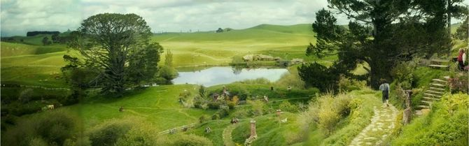

Often compared to the midlands of England, the Shire is a green and flourishing region, where farmlands prosper. Throughout the narrative of TLOTR, the Shire is greatly associated with the themes of peace, prosperity, and most importantly, of home.  
It is from the Shire that Frodo, Sam, Merry and Pippin begin their journey, and they would not come to see it again until the very end of the War of the Ring. This notion of home is often brought up throughout the struggles and perils these Hobbits encounter during their adventures, and their purpose is often described as ‘saving’ the Shire and all they love from the doom of Mordor.

### **ii. Motifs**

As a prominent part of the narrative, the theme of the Shire is perhaps one of the most recognisable, most well-known and loved theme composed by Howard Shore.

Due to the connection between the Hobbits and their homeland, the theme in question serves as both a motif for the Hobbits, and the actual physical location that is the Shire as well as the feelings and emotions it represents during the story’s unfolding.

The Shire is one of the first themes introduced to the audience in *The Fellowship of The Ring.*

Here is the theme representative of The Shire:

TRACK1 The Shire base theme

The tune is heart-warming, comforting and inviting. It is easily relatable to the theme of home that is so often brought up in the story. The melody’s D Major tonality remains mostly in the major mode throughout the entire trilogy, and represents the ideal home that The Shire Represents. This theme has many sub-motifs devised from it, one can count as many as 15 variations on the same base melody and accompaniment.

This setting is realized classically by the orchestra, and used in the hobbit’s recollective moments. The theme often appears as a solo whistle. When required, a stately solo clarinet presents the melody with a shade more melancholy. Shore said “If I don’t use the whistle, clarinet is an elegant substitute for it.”[17]

It is this base theme of the Shire that will be developed into so many sub-themes by Howard Shore. By using what is happening on screen, Shore is able to compliment what the audience is feeling. This will be explored in the “in scene” section

### **iii. In Scene**

As previously discussed, the Shire is a location theme. As such, it has, by many occasions, been modified to suit the needs of the film.

By taking a close look at the introduction of the Shire, the motif takes on what is called its “rural setting”. The rural setting transforms the Shire into a sprightly, Celtic-influenced peasant melody. It represents the simple joy of Hobbiton in musical form. This variation is scored for orchestra and a collection of folk instruments. This sprightly musical palette represents the Hobbit’s gently whimsical life in Hobbiton. After bring introduced in The Fellowship of the Ring, this theme does not reappear until the Hobbit’s return in The Return of the King, solidifying this variation’s link with the Shire.

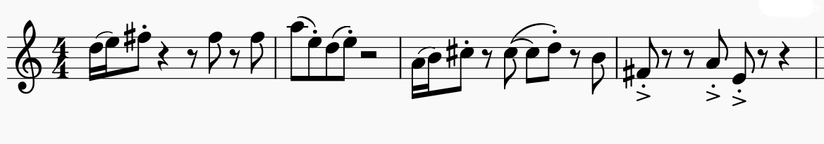

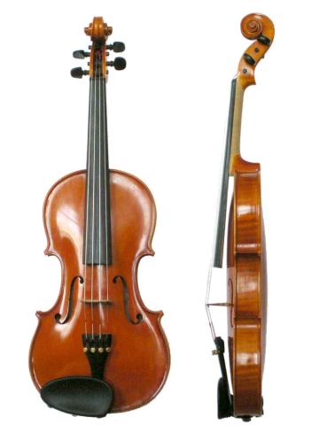TRACK2 The Rural variation

In order to complete this variation’s sense or rurality and country, the instrumentation is very different in comparison to the main base theme. In this particular extract, several instruments were used to make a difference. The fiddle is the most notable. Whilst the fiddle is not unlike the classical violin of the orchestra, the performers will often adapt their playing style, and sometimes even modify their instruments slightly. The playing techniques will also differ slightly, allowing fiddlers greater latitude in bowing and ornamentation. All of this is to produce a very rural sounding violin. Shore very appropriately used this during the expositional introduction to the Shire in the film. [18]

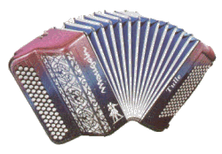Also notable in the rural setting is the use of a musette. A musette is a small, diatonic, accordion-like instrument consisting of a keyboard affixed to bellows. Diatonic here meaning able to play the notes of a particular musical scale. Shore wrote a handful of musette and accordion lines to provide harmonic accompaniment to the Shire’s rural theme.

As demonstrated by the rural variation of the Shire theme, Howard Shore is able to modify a previously set out base theme according to the needs of the screenplay and narrative. This is a reoccurring pattern in Shore’s work, and is the reason his manipulation of leitmotifs is such a notable one. Further use of leitmotifs is explored in the other 2 themes studied in this EPQ.

## **3.2 The Fellowship**

### **i. The Story Briefly**

The Fellowship of the Ring is a group of representative of the different races of Middle-Earth. Appointed at the Council of Elrond, a secret gathering of the foes of Mordor, its mission was to protect and aid Frodo Baggins in his task as the ring-bearer, as he set out to destroy the one ring in the fires of Mount Doom, thus ending Sauron’s dominion of Mordor and destroying the threat to peace. This group of Men, Elves, Dwarves, Hobbits and a Wizard formed a great friendship during their perils together, and the narrative of TLOTR follows the adventures of its members as they are split up and eventually reunited through a series of great perils and adventures.  
There are nine members in the Fellowship:

* 4 Hobbits
  + Frodo Baggins
  + Samwise Gamgee
  + Meriadoc (Merry) Brandybuck
  + Peregrin (Pippin) Took
* 2 Men
  + Aragorn (Strider) Elessar
  + Boromir, son of Denethor II
* 1 Elf
  + Legolas, son of Thranduil
* 1 Dwarf
  + Gimli, son of Gloin
* 1 Wizard
  + Gandalf the Grey (Later Gandalf The White)

Elected to represent all the races present at the Council of Elrond, the Fellowship of the Ring represents the union, bonding and friendship of the group that the story revolves around. Howard Shore made sure to represent this in his work regarding the Fellowship.[19]

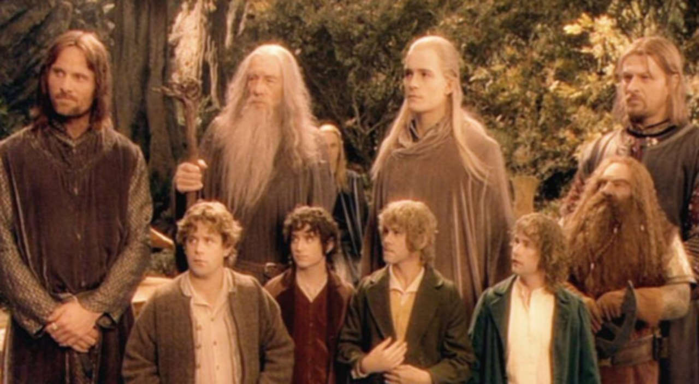

### **ii. Motifs**

As detailed before, the entire story of *The Lord of the Rings* revolves around the adventures of the members of the Fellowship. It comes to no surprise then that this theme is very prominent, and is heard many times throughout the trilogy. Its modifications are used to reflect the state of the Fellowship at different points during the story, and Howard Shore does this very effectively.

The development of the theme of the Fellowship is perhaps the most complex and interesting of all the main motifs written by Shore.  
The Fellowship is, as previously mentioned, a group of individuals. These characters are introduced in chronological order, in the novels as well as the films, and all come together in the same place and at the same time, the famous Council of Elrond, to be united in a common purpose.  
As such, the theme of the Fellowship sees itself very slowly introduced and developed over time, as the number of members of the Fellowship grows slowly as the story progresses. This build-up of thematic material peaks at the Council of Elrond, and after that is used to reflect the state of the Fellowship in the remaining 2 movies.

In fact, Elrond himself does not utter the words

*“So be it, you shall be The Fellowship of the Ring”[20]*  
TRACK3 Elrond creates the Fellowship

to the 9 companions until 1h 45 mins 30 seconds through the first movie, or exactly 46% of the total running time (3h48mins 11 seconds).

This leaves ample opportunity and great lengths of time for Shore to thematically develop the theme of the Fellowship prior to its creation, and to adapt it to any circumstance the characters of the Fellowship go through.

The theme for the Fellowship makes more than 20 separate appearances in the first film alone[21], therefore we will study here only some of the many cases this theme is used in the soundtrack for *The Fellowship of the Ring.*

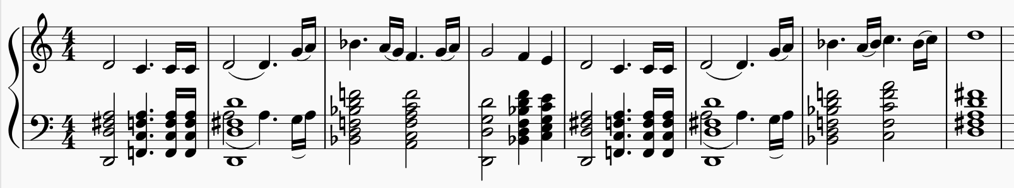

### **iii. In Scene**

As mentioned previously, the fellowship is the subject of much of the narrative in *The Lord of the Rings.* As a result, its theme is omnipresent in all 3 films, and plays a big part in the thematic modifications other motifs undergo. The extract that was just played is the base theme of the Fellowship. The Fellowship theme strikes a unique posture. It is receptive and sympathetic, but at the same time steely and unaffected. It is a theme for a benevolent yet steadfast mission.

There are very, very numerous occurrences of the theme of the fellowship; they cannot all be explored here. However, as this theme represents a group of characters, and their adventures, perhaps the best way to appreciate how Shore made use of it is by exploring its own journey through the story. This motif undergoes countless changes, minor or major, to reflect the adventures of the character. It is some of these changes that will explored in this section.

Like the Fellowship itself, the theme is assembled by pieces throughout the first story, and scattered thereafter. Apart from a single curtain-opening statement of this theme for the *The Fellowship of the Ring* title card at the beginning of the first movie, this theme does not being to appear until members of the fellowship stat forming their group. As Frodo and Sam, the first two, cross into a corn field, officially leaving the shire, we get the very first statement of the Fellowship. It is quiet, not played on the full orchestra, and has a sombre feeling to it. The journey of the fellowship starts here, but the group is not yet complete, just like this theme.

TRACK4 Frodo and Sam crossing the borders of the Shire

In the previous section, the extract of the creation of the fellowship was played. Create by Elrond at his secret council; this is where the fellowship will ever be at its fullest. Shore opens the melody into a fully realized hero’s theme. Shore commented:

“It’s the first time you hear it in its full orchestration. It’s such a great moment. It had to be just right.”

From there on onwards, the Fellowship will never be as complete as it once was. As was told in the resume of the story, this group of friends will be split up, dispersed across Middle-Earth. The Fellowship theme will therefore never be as complete as it was at the council of Elrond, not until the very end, when the Fellowship reassembles. Even by the end of the first film, the fellowship is already shattered, split in 3. Frodo and Sam make their way to Mordor, whilst Aragorn, Gimli and Legolas chase the pack of orcs that hold Merry and Pippin Captive.

The heart of the Fellowship does not, however, lie simply in its members, but also its mission. It is based on the aligned cultures of Middle-Earth, united in purpose. So long as this mission persists in aiding the destruction of the One Ring, some elements of the theme remain.

This masterful reflection of the group’s state in the music shows Shore’s use of the leitmotif effectively. By modifying his music appropriately, he is not only able to reflect what the audience is seeing on screen, but also able to add to it greatly. Whether the audience realises or not that the music they are listening is changing, the soundtrack still plays on their emotions, and perception of the narrative. By subtly bringing the theme back, in different contexts and different states of the Fellowship, Shore helps the progression of the story, and his work builds on the movies to produce the great climaxes that are the creation and reunification of the Fellowship.

## **3.3 Gondor and the Realms of Men**

### **i. The Story Briefly**

Gondor is the name of one of the oldest and most prominent kingdoms in Middle-Earth. Much of the second novel is set in it, as well as nearly the entirety of the third book.

Gondor’s height in power was during its early years. This millennia old Kingdom holds the last true realm of men. Founded by 2 brothers at the end of the second age of Middle Earth, it suffered countless attacks by allies of Sauron, a civil war and a devastating plague that left the kingdom in decline. Ever since the end of the line of Kings, its rule was given over to weaker men.

“The old wisdom that was borne out of the West was forsaken. Kings made tombs more splendid than the houses of the living and counted the names of their descent dearer than the names of their sons. Childless lords sat in aged halls musing on heraldry or in high, cold towers asking questions of the stars. And so the people of Gondor fell into ruin. The line of Kings failed, the White Tree withered, and the rule of Gondor was given over to lesser men.” – Gandalf the White[22]

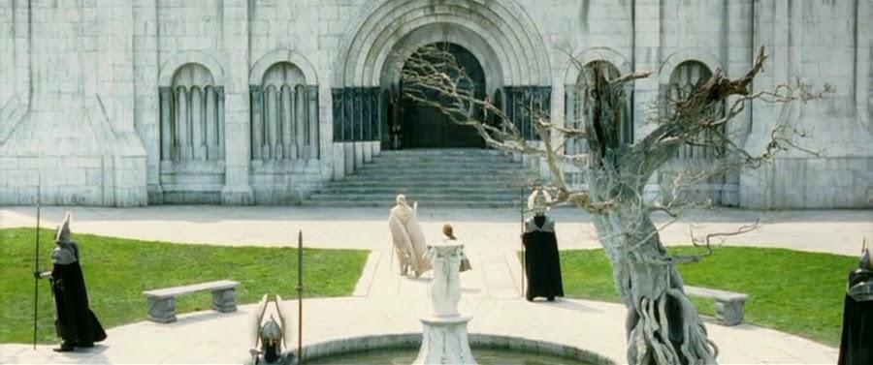*Gandalf and Pippin in Minas Tirith, in front of the White tree of Gondor[23]*

### **ii. Motifs**

As nearly all of the narrative in *Return of the King* revolves in and around the lands of Gondor, Howard Shore made sure to give this theme the importance, stature and prominence to match the kingdom it represents. Heard throughout nearly all of this film, it and its variations are found in many different ranges, instrumentations and characteristics.

Here is the theme that represents the realm of Gondor.

TRACK5 Gondor’s theme

This theme is first heard in *The Fellowship of the Ring* during the council of Elrond. It is played on a lonely trombone whilst Boromir, son of the Steward of Gondor, talks about his father.

As a first exposure to the audience, Shore makes sure that we associate this motif with the realm of Gondor, and with its people. As Boromir displays his dedication to his people and his family, we hear this clear brass theme, tarnished with sorrow and lament; Gondor is not what it used to be. It has fallen into ruins under the rule of the Stewards.

Once the theme begins to occur more consistently, it becomes clear that the music of Gondor receives its own special treatment in *The Lord of the Rings*. As so much of the story depends on the rule of the king, the return of the glory of men in Middle Earth, and the fight against evil, Shore has put much attention and detail in the way the music of Gondor evolves over the 3 films.

The melody exists in two separate settings, each of which beings identically, but go on to end differently. Gondor is first seen and spoken of as a fading society, a once glorious kingdom besieged by enemies from the outside, and crippled by poor leadership from within. Here, The Realm of Gondor finds its melodic climb turn downwards, and this creates the variation of Gondor in Decline.

TRACK6 Gondor in Decline

In *Return of the King*, Gondor struggles to reclaim its proper position governing Middle Earth. Though the path is rough and arduous, throughout the film Gondor does eventually re-establish its prominence in the world. This climb towards greatness is shown throughout the entirety of the third film, and peaks at the end, with the crowning of Aragorn, new King of Gondor in the Fourth Age of Middle Earth.

It is the Gondor in Ascension setting of the base theme that represents this protracted return to power. This setting of Gondor does not being to enter the score only after Gandalf and Pippin pass into the realm to warn Gondor of the impending attack from Mordor, thus directing the story’s final events towards this kingdom and its rise.

TRACK7 Gondor in Ascension

Notice the second half of this theme. It is built off the first three pitches of the Fellowship’s theme.  
This draws a connection between the Fellowship’s mission and its impact upon Gondor.

### **iii. In Scene**

As Gondor plays such a vital role in the third film, it is very often heard throughout its entire soundtrack. As a result of this, there are nearly a dozen instances of the theme being modified in some way to suit the scene, or to add elements to it.

As the music of Gondor is the central-most theme *to Return of the King*, it is the one that plays when the opening title is displayed on screen. Due to the length of the film, this does not actually happen until 9 minutes and 50 seconds from the start of the movie. However, the build up to it and setting of the scene already gives insight into Gondor, the concluding story that is about to unfold, and sets the tone for this final and third act of The Lord of the Rings.

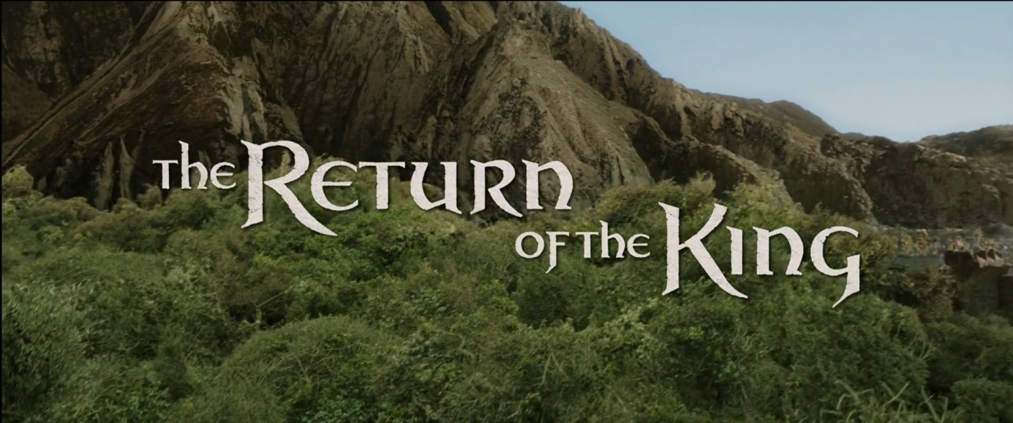During this scene Aragorn, Gimli, Gandalf and Legolas accompanied by riders of Rohan make their way through the woods as the Fellowship themes out. As the camera tilts back the *Return of the King* title card appears, the theme shifts and French horns intones the opening of the Realm of Gondor theme. The Fellowship theme is incomplete; as is the company we see riding through the forest. It serves to let the audience quickly recognize the members of this company we have so often heard this theme associated with. But, this third and final movie’s focus is not on this Fellowship, or at least not directly. This is why the horns very quickly embrace the theme of Gondor, yet with uncertainty, and not glory and pride like some other renditions of the same theme; the war is not over, and the greatest challenges are yet to be faced by Gondor.

TRACK8 The Title screen soundtrack

The first extract of this theme given earlier (TRACK5) is heard at the council of Elrond. It is played in the background to Boromir, the only man from Gondor at the council, as he describes his people’s struggle against the dangers faced by Gondor.

*“Long has my father the steward of Gondor kept the forces of Mordor at bay. By the blood of our people are your lands kept safe. Give Gondor the weapon of the enemy. Let us use it against him”[24]*  
TRACK9 Boromir saying this at the council of Elrond

Here we hear again, played on long and tender trombones, the theme of Gondor in decline. We make a connection with this land that Boromir speaks so passionately about. Gondor may be in decline, but they remain proud, and brave in the face of the armies of Mordor. Boromir’s plea to the council to let them use the Ring of Power is poignant. This is the first instance of the Gondor in Decline theme ever heard.

However, Gondor is not the main focus of the story until the third film begins. Consequently, the motif is heard but very rarely in *The Fellowship of the Ring* and in *The Two Towers*. However, it becomes the de facto theme for the third film, whose story develops within in greatly. This is why we do not get further development of this theme until the third movie.

Here is the first instance of the Gondor in Ascension theme being heard. It occurs when Gandalf and Pippin, two members of the Fellowship, travel on horseback to Gondor, bringing words of warning against the impending attack on the capital city of Gondor, Minas Tirith.

The Fellowship is yet to reach Minas Tirith; many of its members are far away. However Gandalf and Pippin are charging towards it. An excited, muscular Fellowship theme presses the duo across Middle Earth until, by the crossing of a stream, they pass into the borders of Gondor.  
As we here this, Gandalf announces the following:

“We’ve just passed into the realm of Gondor”  
TRACK10 Gandalf saying this to Pippin

Horns and strings quickly announce their arrival with a proud summoning of the main theme of Gondor. This reinforces this theme’s association with Gondor, only this time portraying the kingdom and its city is a more positive light. It sets the base theme that will be prominent throughout the entire third theme. Shore described this instance of the theme as “quite stately, and it is played on the brass. … It has a bit of a feeling of grandeur to it”[25].

And thus, the theme of Gondor is one that carried heavy meaning and representation. Shore uses it to not only represent the land it is named after, but also the might of old of men, and their position in the musical multitude that is Middle-Earth.

# 4 Conclusion

As has been stated before, the work done by Howard Shore on *The Lord of the Ring* is as unprecedented as it is detailed and complex.

Throughout the production of this project, it was made very clear that the work done here would not nearly suffice to successively analyse and be able to judge Howard Shore’s score. The research done served its purpose, but also revealed just how much more work could be done, on the same topic and themes alone. Whilst a conclusion can be drawn on the work studied specifically in this project, it should not be used to represent the score in its entirety. The work done on the themes chosen in this project is indicative of their importance to the trilogy. The motifs were chosen as part of the ones that contribute much in each scene they are in. Whilst there are many more, some of great importance too, in the rest of the soundtrack, the 3 chosen here were judged to be the best sample to accurately represent the extent of Shore’s ability to modify each of these themes, and their importance to the scene they are contributing in.

Throughout this project, the depth of Howard Shore’s work was shown, and its structures was laid out in a way that makes clear the different releases of the films’ soundtracks, and how voluminous each CD is. In addition to this, the brief work that was done here to analyse the musical modification of specific leitmotif shows us how Howard Shore used such musical devices as the leitmotif to great effect. By detailing the scenes which use certain tracks in conjunction with the music played in these scenes, it was shown that it is possible to draw much meaning and significance from changes made to the themes. This project has shown that Howard Shore’s main “musical device” was the leitmotif, and that he based any other musical, instrumentational or orchestral decisions around the structure of his soundtrack, and therefore around the hundreds of leitmotifs he composed.

Regarding all of this information a rather subjective but informed point of view may be taken regarding the soundtrack. Howard Shore has composed, factually, one of the most successful and well known soundtracks of all time. Whilst this could be attributed to many aspects of it, as discussed before, it can be argued that the main source of its popularity and recognisability is due to its consistent and pertinent use of leitmotifs, in a way that makes the audience pay more attention to the music while viewing the film. Shore’s work has certainly set the new bar in what can be achieved using the leitmotif and, personally, this bar has yet to be reached by any movie’s soundtrack since its release.

# Bibliography & Filmography

Adams, D., 2010. *The Music Of The Lord Of The Rings.* s.l.:Alfred Music.

CouncilOfElrond, n.d. *CouncilOfElrond.* [Online]   
Available at: http://www.councilofelrond.com/  
[Accessed 04 2019].

Empire Online, n.d. *Best Movies.* [Online]   
Available at: https://www.empireonline.com/movies/features/best-movies/  
[Accessed 2019].

epicsound, n.d. *The Relevance Of Temp Tracks.* [Online]   
Available at: https://www.epicsound.com/resources/temptracks/

HowardShore.com, n.d. *HowardShore.com.* [Online]   
Available at: www.howardshore.com  
[Accessed 2019].

lotr score analysis project, n.d. *Lord of the Rings Score Analysis Project.* [Online]   
Available at: http://www.melson.nl/lotr/index.php  
[Accessed 2019].

lotr.fandom, n.d. *https://lotr.fandom.com.* [Online]   
Available at: https://lotr.fandom.com/wiki/Ring-inscription  
[Accessed 2019].

New Line Productions, n.d. *The Lord of the Rings - Soundtrack.* [Online]   
Available at: http://www.lordoftherings-soundtrack.com/  
[Accessed 2019].

Sadoff, R. H., 2006. *The role of the music editor and the 'temp track' as blueprint for the score, source music, and scource music of films.* s.l.:s.n.

Sadoff, R. H., 2006. The Role of the Music Editor and the 'Temp Track' as Blueprint for the Score, Source Music, and Scource Music of Films. *Popular Music,* 25(2), pp. 165-183.

*The Lord of the Rings: The Fellowship of the Ring Extended Edition.* 2002. [Film] Directed by Peter Jackson. s.l.: New Line Cinema.

*The Lord of the Rings: The Return of the King Extended Edition.* 2004. [Film] Directed by Peter Jackson. s.l.: New Line Cinema.

*The Lord of the Rings: The Two Towers Extended Edition.* 2003. [Film] Directed by Peter Jackson. s.l.: New Line Cinema.

The Star, 2007. *Tolkien Proves he's still the king.* [Online]   
Available at: https://www.thestar.com/entertainment/2007/04/16/tolkien_proves_hes_still_the_king.html  
[Accessed 2019].

Wikipedia, 2019. *List of accolades recieved by The Lord of the Rings film series.* [Online]   
Available at: https://en.wikipedia.org/wiki/List_of_accolades_received_by_The_Lord_of_the_Rings_film_series  
[Accessed 2019].

Wikipedia, n.d. *Leitmotif.* [Online]   
Available at: https://en.wikipedia.org/wiki/Leitmotif#cite_note-3  
[Accessed 2019].

Wikipedia, n.d. *The Lord of the Rings.* [Online]   
Available at: https://en.wikipedia.org/wiki/The_Lord_of_the_Rings  
[Accessed 2019].

For any questions, requests or inquiries, please immediately contact

Nathan Guth  
[guth.nathan@gmail.com](mailto:guth.nathan@gmail.com) or [guth.nathan@st-georges.lu](mailto:guth.nathan@st-georges.lu)  
Candidate number: 1717  
Centre number: 74252

1. Image credits: (lotr.fandom., n.d.)
2. Please contact the centre or author of this EPQ for any inquiries about reading any necessary audio/video files provided with this project. Contact information will be provided at the end of this document.
3. Image credits: (Wikipedia, n.d.)
4. (The Star, 2007)
5. (Empire Online, n.d.)
6. Image credits: (lotr.fandom, n.d.)
7. (Adams, 2010, p. xii)
8. (Sadoff, 2006)
9. (epicsound, n.d.)
10. (Sadoff, 2006, pp. 165-183)
11. (Wikipedia, 2019)
12. (New Line Productions, n.d.)
13. Image credits: (HowardShore.com, n.d.)
14. (Adams, 2010, p. xi)
15. (Adams, 2010, p. xi)
16. (Wikipedia, n.d.)
17. (Adams, 2010, p. 23)
18. Image Credits: (Wikipedia, n.d.)
19. Image credit: (The Lord of the Rings: The Fellowship of the Ring Extended Edition, 2002)
20. (CouncilOfElrond, n.d.)
21. (lotr score analysis project, n.d.)
22. (The Lord of the Rings: The Return of the King Extended Edition, 2004)
23. Image Credits: (The Lord of the Rings: The Return of the King Extended Edition, 2004)
24. (The Lord of the Rings: The Fellowship of the Ring Extended Edition, 2002)
25. (The Lord of the Rings: The Return of the King Extended Edition, 2004)